|  |  |  |  |
| --- | --- | --- | --- |
| Date  Cathedral Kids | Day | Colour | Theme |
| 19 July 2020 | Parable of the Wheat and the Weeds | Green | The Kingdom of Heaven |
| Bible verse:- Matthew 13:24-30, 36-43 | | | |
| Background:- Jesus told stories to people to teach them about God.  Who doesn’t love a good story! I know I do!  When we listen carefully to stories we have the chance to learn all sorts of things about life, people and God. In the parable about the wheat and the weeds there are many things that Jesus is trying to teach the people who listened to it. One of those things is that the world is like the farm. It has both good(the wheat) and not so good (the weeds). We have to live with both, and as we get older we hopefully will become more able to tell the difference between the two. Hopefully we will learn how to always recognise and choose what is good. Another way to think about this story is as though we have both good and not so good in us. It’s how we choose to use it that makes our actions like weeds(not so good) or like wheat(good). Another way is the idea that God is like the farmer and at the right time God will judge what is a weed and what is wheat, something that we find hard to do sometimes. In God’s Kingdom all that is good (the wheat) will be there. Let’s be thankful for God’s loving judgement and God’s ability to deal with what are weeds within our own life and in the world that surrounds us. | | | |
| Further Activities   1. Watch the Children’s Church video for this week. 2. Go into your garden. Can you tell which plants are weeds and which are like wheat – the useful ones? 3. Make a prayer space in a corner of your room (If you haven’t already). You could have a little table, on the table put a cross and a candle (a battery operated one would be safest). On the plant picture on the following page write the names of people you care about who could do with knowing some more about God’s love and say a prayer for them. 4. Colouring sheet. 5. Put a plant in a pot and watch it grow. You might choose a vegetable plant or a flowering plant. Either, with the right care, will produce good things. 6. I’d love to see photos if you’re allowed to email them in. Ask your parents to help you. The address is:- [families@graftoncathedral.org.au](mailto:families@graftoncathedral.org.au) | | | |



[This Photo](http://flowercoloringpage.blogspot.com/2013/04/flower-coloring-pages-for-preschoolers.html) by Unknown Author is licensed under [CC BY](https://creativecommons.org/licenses/by/3.0/)

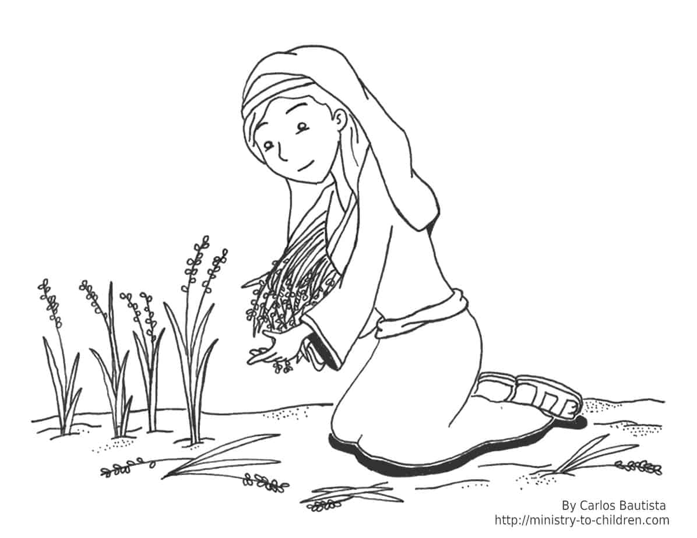

[This Photo](https://ministry-to-children.com/ruth-coloring-page/) by Unknown Author is licensed under [CC BY-SA](https://creativecommons.org/licenses/by-sa/3.0/)